REPLY FORM
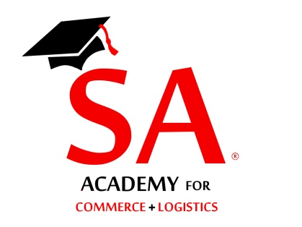
Training Programme on incoterms
Please send all applications preferably by email
Attn: Shippers’ Academy Colombo

ATTN: Secretary
Email: enquiries@shippersacademy.lk

Fax: +94112874065
Tele: 077-3820703 /0113560844

Please reply on or before 16th December 2019

Shippers’ Academy Colombo
105, Hunupitiya Lake Road
Colombo 02

Reference your circular dated 01st December 2019; we have the pleasure in nominating the following representatives to attend the Training programme on Negotiating Freight Rates on the 17th December 2019 at the Plastics & Rubber Institute, Rajagiriya

NAME OF COMPANY :…………………………………………………………………………….

ADDRESS :……………………………………………………………………………..

TEL NOS :……………………………MOBILE:……………………………………..

FAX NO. :……………………E-MAIL………….……………………………………

NAME DESIGNATION Mobile E-mail

1)……………………………………………. ………………… …………………….. …………………..

2)……………………………………………….. ………………… ……………………. …………………..

3)……………………………………………….. ………………… ……………………. …………………..

4)……………………………………………….. ………………… ……………………. …………………..

5)……………………………………………….. ………………… ……………………. …………………..

Attached please find Cheque No:……………/ Bank ….….for Rs………………being participation fee at the above forum.

Cheques should be drawn in favour of “Shippers’ Academy Colombo (Pvt) Ltd” (Rs. 6,000/- per participant) –
3 or more participants- 20% discount

Name…………………………………….. Signature………………………..

Designation:……….…………………… Date:…………………………….

