REPLY FORM

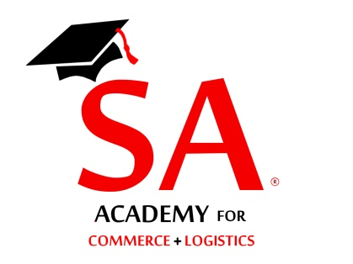
Training Programme on Bills of Lading
Please send all applications preferably by email
Attn: Shippers’ Academy Colombo

ATTN: Secretary
Email: enquiries@shippersacademy.lk

Fax: +94112874065
Tele: 077-3820703 /0113560844

Please reply on or before 26th January 2018

Shippers’ Academy Colombo
105, Hunupitiya Lake Road
Colombo 02

Reference your circular dated 02nd January 2018; we have the pleasure in nominating the following representatives to attend the Training programme on Bills of Lading on the 27th January 2018 at the Ceylon Chamber of Commerce.

NAME OF COMPANY :…………………………………………………………………………….

ADDRESS :……………………………………………………………………………..

TEL NOS :……………………………MOBILE:……………………………………..

FAX NO. :……………………E-MAIL………….……………………………………

NAME DESIGNATION Mobile E-mail

1)……………………………………………. ………………… …………………….. …………………..

2)……………………………………………….. ………………… ……………………. …………………..

3)……………………………………………….. ………………… ……………………. …………………..

4)……………………………………………….. ………………… ……………………. …………………..

5)……………………………………………….. ………………… ……………………. …………………..

Attached please find Cheque No:……………/ Bank ….….for Rs………………being participation fee at the above forum.

Cheques should be drawn in favour of “Shippers’ Academy Colombo (Pvt) Ltd” (Rs. 3,500/- per participant)

Name…………………………………….. Signature………………………..

Designation:……….…………………… Date:…………………………….

